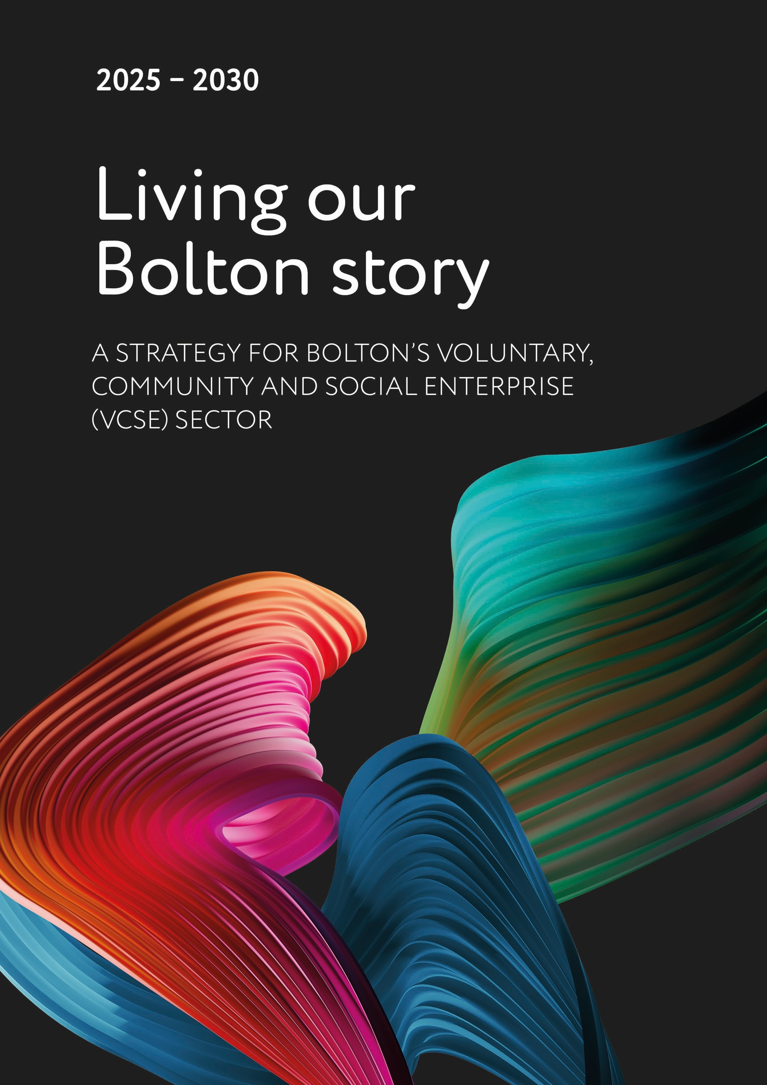

# **2025-2030 Living Our Bolton Story: A Strategy for Bolton’s Voluntary, Community and Social Enterprise (VCSE) Sector.**

**CONTENTS**

1. **Foreword:** The VCSE Co-Design Group.
2. **Introduction:** Celebrating the impact of Bolton’s VCSE Sector.
3. **Reflections:** Progress made since Aspiring and Achieving - VCSE Strategy 2019.
4. **A New Strategy:** A Five Year Living Strategy, The Greater Manchester Accord and the Bolton Vision, Strategy priorities, Strategy priorities explained.
5. **Next Steps:** Call to action and Case Studies.

## **Foreword:**

**The VCSE Co-design group.**

**We are Bolton’s VCSE Co-Design Group,** a strategic working partnership of Bolton’s VCSE and public sector organisations.

**Bolton’s VCSE secto**r supports the people of Bolton in many ways. From enabling learning, improving health and wellbeing to sourcing and supplying emergency food and essentials, they are a vital part of Bolton life, often preventing potential crisis situations.

**The VCSE sector in Bolton is strong because it works in collaboration with others**, the connection with community and partner organisations ensures that positive changes in often difficult circumstances are made:

* We are stronger together.
* We proactively develop solutions to benefit Bolton people.
* We work together and support each other to create wider opportunities to increase positive outcomes for Bolton communities than would be provided if working alone.
* We value transparency, fairness and equality.
* We have a track record of providing innovative solutions to unprecedented challenges.
* We are moving forward with a refreshed drive and purpose.
* Our strategic focus is the Bolton Vision.

**The following Bolton organisations are currently represented on the VCSE Co-design group:**

* Bolton CVS.
* Bolton Wanderers in the Community.
* Bolton Together.
* Bolton Council.
* Bolton at Home.
* Greater Manchester Mental Health FT.

Thank you for joining us on our journey that follows on from our previous strategy ***Aspiring* *and Achieving*** which was published in 2019. Much has happened since its launch, notably the covid pandemic and subsequent impact on the cost of living.

The formation of the VCSE Co-design group, establishment of Bolton CVS as Bolton’s infrastructure organisation and progress in the development of Bolton’s Fund significantly supported and strengthened the response to these unprecedented challenges.

This ***Living*** strategy sets out our direction for the next five years of ***our Bolton Story.***

## **Introduction:**

**Celebrating the impact of Bolton’s VCSE Sector.**

**Bolton’s VCSE Sector makes a difference…**

The VCSE sector in Bolton is vibrant and diverse embracing a huge variety of organisations. As we set out our new strategic direction it is helpful to consider our dynamic Bolton VCSE landscape.

In Bolton there is a long and proud history of the VCSE working with local communities to deliver localised solutions to challenges as well as providing fun and friendly places to be and things to do.

The Bolton VCSE sector makes a difference to people’s lives, providing activities and support to:

* improve wellbeing.
* Develop community resilience and strength.
* Support and encourage physical activity.
* Empower individuals through education and training.
* Support environmental sustainability.
* Support employment opportunities and key skills.

The State of the Sector Report (2021) noted the size, scale and economic contribution from the sector:

* 1,672 voluntary organisations, community groups and social enterprises making a difference in Bolton.
* 11% of the sector identify as being a social enterprise.
* 86% of organisations have at least one source of non-public sector funds, bringing significant value.
* 58,259 volunteers (including committee/board members), giving 211,223 hours each week valued at £106m per annum (based on real living wage £9.50 per hour).
* £119.4m total income of the sector (2019/2020).
* 59% of the organisations have used their reserves in 2019/2020 (35% due to COVID).
* 64% have had some direct dealings with other VCSE organisations, 83% with Bolton Council and 55.7% with private organisations.
* 71% are micro-organisations.

Main areas of work in Bolton’s VCSE sector…

* 52% community development.
* 40% physical activity, sport and leisure.
* 33% well-being, health and social care.
* 19% economic well-being.
* 16% education, training and research.
* 16% environment and sustainability.
* 11% accommodation and housing.
* 10% religious and faith-based activity.
* 9% equalities and civil rights
* 7% arts, heritage and culture.
* 5% international development.
* 5% criminal justice.
* 3% animal welfare rights.
* 2% campaigning and lobbying.
* 1% travel and transport.
* 1% capacity building and other support for voluntary or community organisations.
* 1% support and services for social enterprises and social entrepreneurs.
* 1% other charitable, social or community purpose.

Main geographical areas of work…

* 57% across the whole Bolton Local Authority area.
* 53% particular Bolton neighbourhoods and communities.
* 10% across more than one Greater Manchester Local Authority area.
* 6% across the city region of Greater Manchester.
* 4% regionally across the North West.
* 2% nationally.

## **Reflections:**

**Progress made since the VCSE 2019 Strategy Aspiring and Achieving:**

The strategy placed a strong emphasis on shared accountability and outcome-based activity that

linked directly to the Bolton Vision Delivery Plan. The 2019 strategy set in motion the creation of

the VCSE Co-Design group, the setting up of Bolton CVS as the VCSE local infrastructure partner

and ultimately the development of Bolton’s Fund.

**Priority One: Creating the right conditions for the VCSE Sector in Bolton to flourish.**

Progress Made:

The VCSE Co-Design Group was formed to drive the development of the strategy. The group embraced coproduction, flexibility and action to enable positive outcomes for Bolton people. The ability of the group to come together in this way allowed various funding and commissioning activities to be directed to community groups to support Bolton communities:

* Bolton’s fund was established.
* Preventative Providers commissioned.
* Community Champions commissioned.

A Memorandum of Understanding was developed to support collaborative working, this has been superseded by the Greater Manchester VCSE Accord.

Bolton CVS was commissioned as the VCSE infrastructure support partner in 2019 to bring stability and support to the sector. This has enabled the provision of further developmental support across the sector:

* Training courses.
* Support with development of governance and constitutions.
* Support for social enterprises, Proper Good.

**Priority Two: Implement a new way of distributing funding to the VCSE Sector in Bolton, The New Bolton’s Fund.**

Progress Made:

Bolton’s Fund was established. The fund has enabled smarter funding decisions based on the ability to direct resources to where it is needed:

* Outcomes linked to the Bolton Vision outcomes.
* Systematic in approach and scope.
* Transparent – all decisions are taken by trained assessors.

**Bolton’s Fund:**

**In December 2024, a Bolton’s Fund 5th Birthday event will kickstart celebrations of the impact of Bolton’s VCSE sector.**

Since 2019, the development support provided by Bolton CVS who are Bolton’s VCSE infrastructure organisation combined with the launch of Bolton’s Fund has significantly contributed to the ability of the Bolton VCSE sector to respond to unprecedented challenges.

* Bolton’s Fund is now the flagship VCSE grants programme covering the Metropolitan Borough of Bolton, five years on it has distributed over £6.5 million of funding to Bolton VCSE groups.
* Bolton’s Fund plays a vital role in driving innovation and fostering projects aimed at benefitting people and communities.
* Bolton’s Fund has been established for Bolton people, as such, applications for Bolton’s Fund grants are assessed by a team of independent, trained community and cross sector partner volunteers.

Since Bolton’s Fund began in 2019, it has proven to be a flexible funding model, it was utilized to quickly direct funding to grassroots community groups during the COVID-19 pandemic and subsequent cost of living challenge.

Groups have been able to directly support Bolton people at a community level, particularly those who may not otherwise engage with public sector services. Vital essentials such as food and clothing were distributed to people along with health, wellbeing and digital support.

The management of Bolton’s Fund provides more than financial support for Bolton VCSE Groups. VCSE infrastructure partner, Bolton CVS provide developmental support in establishing governance processes, financial and data management and safeguarding. This support has contributed to the growth of VCSE groups in Bolton, some have become social enterprises, others have been commissioned by the council and other Bolton anchor organisations to deliver services.

Whilst developing the new VCSE Strategy the Bolton’s Fund model has been refreshed. The rationale for this change was to further increase accessibility to the fund by Bolton grassroots VCSE groups. This has been achieved by moving more towards a rolling programme model, strengthening the pathways to developmental support and encouraging frequent applicants to apply for more appropriate longer term funding or income generation.

Bolton Council are currently the main contributor to Bolton’s Fund, however other Bolton based organisations contribute to the fund either financially or in-kind. Further diversification of investment to Bolton’s Fund is being explored as part of this wider VCSE Strategy.

Our new **Living** strategy will strengthen this collaborative work for the next five years to continue making a difference…

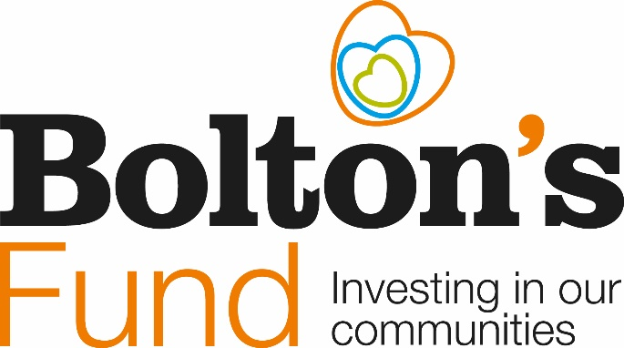

## **A New Strategy:**

**The impact of our collaborative approach…**

The collaborative way that the Bolton VCSE sector and public sector and public services work together provide the foundations to pro-actively and positively support Bolton people. The diagram below highlights the work of the Preventative Providers Collaborative.

A summary of our reach and impact:

* 986 active volunteers contributing over 130,000 volunteer hours.
* Supported 30,123 people.
* Have over 600 weekly staff hours.
* Build social value with local providers employing local people.
* Keep Bolton’s people well connected and independent for longer.
* Average preventative providers grant awarded £29,308.

**Living Our Bolton Story****: A Strategy for Bolton’s VCSE Sector and partners, 2025 – 2030.**

**A Five-Year Living Strategy:**

The VCSE Co-design Group is committed to continuing supporting the collaborative work of Bolton’s VCSE sector and its partners over the next five years to maximise positive impact for Bolton. The strategy will undergo a review each quarter, with a more in-depth review in two years.

The strategy and accompanying action plan will be placed on the Bolton CVS website and updated in line with the five year review process.

The Greater Manchester Accord and the Bolton Visionhas informed our strategic priorities and action plans.

**We embrace the Bolton Vision.**

The collaborative working between Bolton’s VCSE sector, public and private partners make a significant contribution to the prosperity of Bolton.

**We acknowledge the Greater Manchester VCSE Accord.**

The Greater Manchester VCSE Accord is a three-way collaborative agreement between:

* the Mayor of Greater Manchester, Combined Authority.
* the Greater Manchester Integrated Care System.
* the Greater Manchester VCSE sector.

The Accord provides focus on how we work together to improve outcomes for Greater Manchester’s communities and citizens. The Accord been endorsed through the executive structures of all GM Local Authorities. Further information about the GM VCSE Accord can be found here: [GM VCSE Accord 2021-2026](https://gbr01.safelinks.protection.outlook.com/?url=https%3A%2F%2Fwww.greatermanchester-ca.gov.uk%2Fmedia%2F5207%2Fgm-vcse-accord-2021-2026-final-signed-october-2021-for-publication.pdf&data=05%7C02%7CVictoria.Lewis%40bolton.gov.uk%7C982873ffced84fcb5b6a08dd0fc5b5a8%7C43780061ae5d41df8197c8bc4da9be1e%7C0%7C0%7C638684064007938247%7CUnknown%7CTWFpbGZsb3d8eyJFbXB0eU1hcGkiOnRydWUsIlYiOiIwLjAuMDAwMCIsIlAiOiJXaW4zMiIsIkFOIjoiTWFpbCIsIldUIjoyfQ%3D%3D%7C0%7C%7C%7C&sdata=%2BcGoYIAmzXWCpEOKgJYZb7FBvfuW83lbcd0Fdq9T4Ho%3D&reserved=0).

**The New Strategy Priorities:**

Priority One: Sustainability.

* Maximise funding opportunities.
* Be commission ready.

Priority Two: Impact.

* Tell the VCSE social value story.
* Celebrate Bolton’s Fund 5th Birthday.

**Strategy Priorities Explained:**

The Strategy focusses on two key priorities, ***Sustainability and Impact.***

**Priority One: Sustainability.**

We aim to provide the means for Bolton’s VCSE sector and its partners to explore what **sustainability** means through working collaboratively more can be achieved. To direct our work, we have identified two key work areas, ***Funding and Commissioning:***

**Maximise funding opportunities:**

* Funders of the VCSE Sector in Bolton are under budget and resource pressures whilst the demand on the sector is increasing. We aim to support activity that will bring diversified income streams to the sector and explore creative ways for the sector to generate its own income.
* Bolton’s Fund has undergone a change, there has been a move to a rolling programme, further strengthening the pathways to developmental support and encouraging frequent applicants to apply for more appropriate longer term funding or income generation. Bolton’s Fund, however, is not a long-term solution to the funding of Bolton’s VCSE sector. It is a priority to provide resources, support and encouragement to empower the VCSE sector to access other funding opportunities.
* **A VCSE collaborative has been established to explore funding opportunities and partnership working with other groups to apply for funding has been established.**

**Be Commission Ready:**

* Bolton’s VCSE Sector work in connection with their locality and are often best placed to provide preventative services.  We aim to develop the right conditions for VCSE groups to be able to apply and be successful in obtaining contracts and commissions to provide further stability for their organisation and the work they do. Activities that are being developed are:
  + **The establishment of commissioning as a programme of work in the VCSE Co-Design group through membership and activity.**
  + **Development of co-produced Flexible Purchasing System framework for the VCSE sector to access work commissioned by the Local Authority.**
  + **Development of an offer of support for organisations to becoming ‘commission ready’ via Bolton CVS.**
  + **Develop a shared understanding across the Bolton system around the benefits and challenges to VCSE commissioning.**

**Priority Two: Impact.**

**Interlinking with priority one, the second strategy priority, *Impact* aims to celebrate the positive contribution that the VCSE sector has on the prosperity of Bolton. To direct our work, we have identified two key work areas, *Storytelling and Celebration***

**Tell the VCSE social value story:**

* Groups applying for funding grants or commissioned contracts with public sector organisations are required to provide evidence of their work. This, however, can be a vulnerable place as there is pressure to tell a good story but also reflect on challenges.
* **We aim to provide support and resources to encourage VCSE organisations to evidence their impact, tell their social value story and impact on the prosperity of Bolton as a whole.**

**Celebrate Bolton’s Fund 5th Birthday:**

* In December 2024, a Bolton’s Fund 5th Birthday event will kickstart celebrations of the impact of Bolton’s VCSE sector.
* **We will publish a programme of events and activities that will celebrate the impact of Bolton’s VCSE Sector in 2025.**

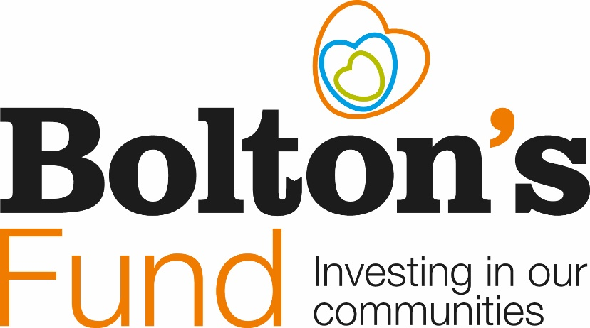

## **Next steps:**

**A Call to Action!**

Thank you for joining us on our journey and ***Living Our Bolton Story…***

Follow the links below.

**An Operations and Engagement Plan has been developed.**

Please follow the link below to the Bolton CVS website to be part of the action: [Bolton's Fund - Bolton CVS](https://gbr01.safelinks.protection.outlook.com/?url=https%3A%2F%2Fwww.boltoncvs.org.uk%2Ffunding%2Fboltons-fund-2%2F&data=05%7C02%7CVictoria.Lewis%40bolton.gov.uk%7C982873ffced84fcb5b6a08dd0fc5b5a8%7C43780061ae5d41df8197c8bc4da9be1e%7C0%7C0%7C638684064007966639%7CUnknown%7CTWFpbGZsb3d8eyJFbXB0eU1hcGkiOnRydWUsIlYiOiIwLjAuMDAwMCIsIlAiOiJXaW4zMiIsIkFOIjoiTWFpbCIsIldUIjoyfQ%3D%3D%7C0%7C%7C%7C&sdata=8IrbH9yIwZx99LRp3YC%2B4odDY9ridNpdIIM4xkEAL9w%3D&reserved=0)

**Case Studies**

The following case studies tell the story of the personal impact that partnership and collaborative working impacts the wellbeing and prosperity of Bolton, the case studies reflect the Bolton Vision Priorities in place at the time of delivery.

**Start Well:**

**Case Study: The Family Hubs and Start for Life programme.**

Family Hubs are for children and young people aged 0-19 (up to 25 for those with special educational needs and disabilities (SEND) and their families.

They join up and enhance services delivered across Bolton that help parents and carers access the support they need when they need it.

A key part of this programme is to match individuals seeking to volunteer with organisations who run activities in the Family Hubs. The activities include:

* **Breastfeeding Together** weekly drop ins for pregnant and breastfeeding parents.
* **Bolton Toy Library**, who provide mother and baby groups, family drop ins and stay and play sessions for children with special educational needs.
* **Little Bats Learning**, who offer a stay and play session based on the Forest School model.

A mother and a child playing with toys


**Live Well:**

**Case Study: Bolton Wanderers in the Community – Fit Fans.**

Fit Fans is a 12-week weight management programme for local people. It encourages day to day adjustments to enable a healthier lifestyle. Each session incorporates a circuit session in the stadium concourse. Members of the Bolton Wanderers coaching team help to deliver the sessions and share tricks of the trade he’s to give an insight into how training puts you in good stead for life.

[FIT FANS - (efltrust.com)](https://www.efltrust.com/FITFANS/).

**Case Study: Bolton Digital Skills Programme.**

The Bolton Digital Skills programme is a partnership between Bolton Wanderers in the Community, Bolton CVS, and Lightful.

Over the course of six months, this collaborative effort has equipped 50 local charities with the confidence and skills necessary to thrive in the digital landscape.

The programme addressed the digital skills gap within the charity sector, with the use of digital tools identified as a leading area of concern for many of the 1,672 organisations operating in the town.

One of the charities that participated in the programme is Sapphire Partnership. Their very digital campaign #dontdismyability. challenges the misconceptions and stigma often experienced by young people with a disability.

An example of the Don't Dis My Ability

A person with pink hair and glasses standing in front of a wall with hearts

The caption reads 'Don't Dis My Ability!' I am Lauren, I have a voice. 

**Age Well:**

**Case Study: Asian Elders Resource Centre “Unity in the Community” event.**

The aim of the gathering, is for people from across Bolton’s diverse communities to spend time with each other, sharing stories, food and laughter.

In amongst the live music, a sweet dish competition and a raffle, there were also stalls from other VCSE groups, and health professionals, providing important information about health and wellbeing.

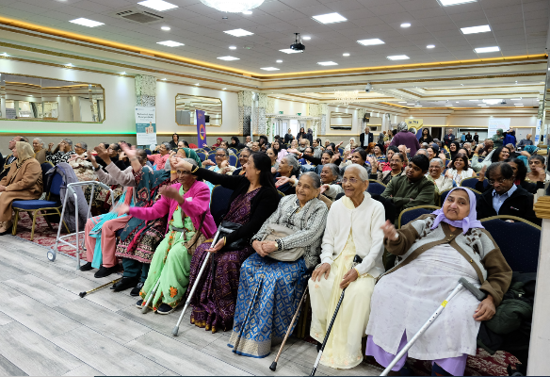

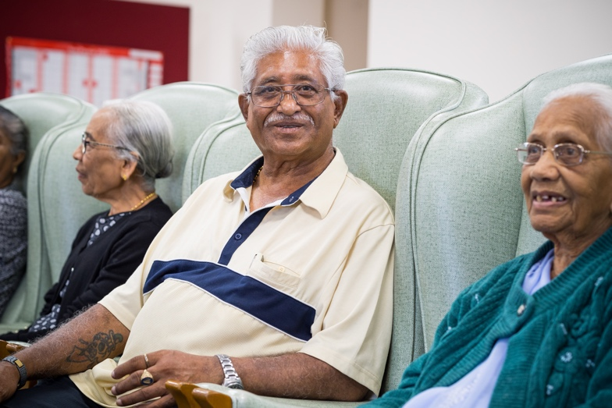

**Economic Prosperity:**

**Case Study: Proper Good.**

Proper Good is a programme of enterprise development support, and social investment, for social enterprises across Greater Manchester. It is jointly funded by Better Society Capital and Access – The Foundation for Social Investment.

It is one of six programmes across England that aim to support the growth and sustainability of local social economies to help reduce poverty and inequality. Proper Good Bolton is hosted by Bolton CVS and is working to support, connect and collaborate with social entrepreneurs in Bolton to build a strong eco-system of social enterprises as part of a resilient social economy.

Now in its third year, Proper Good is designed by a cross-sector steering group to help social enterprises diversify, develop and thrive. Bolton Proper Good’s provides a social enterprise network, a business development mentoring and grant programme and workshops, all of which are led by entrepreneurs who know how to run proper businesses that do good in their communities.

**“I wanted to share some positive news - since being on your (mentoring) programme Recycle-IT are in such a better place and ready for investment now.”** John from Recycle IT.

**“Proper Good Bolton is both the biggest and the most important support function for UK Funding Futures CIC, we are an example of a social enterprise that has engaged and benefited from Proper Good at every single stage of our journey.”** Billy from UK Funding Futures CIC.

Future plans include supporting social enterprises to be commissioning-ready, in corporate supply chains and the development of a cross-sector legacy of support after Proper Good funding ends.

Two women holding a sign showing the Proper Good Logo which states 'No-Nonsense support to start or grow your social business'. 


**Clean and Green:**

**Case Study: St Cuthberts Parish Church.**

Bolton’s Fund awarded a small grant of £1,713 to fund a project to create an accessible wildlife garden.

The grant was used to fund plants and seeds, some essential gardening tools and materials and the costs of installing a pond on the site. An unused area turned into a haven for bees, butterflies, bugs and birds. This area of Bolton has small pockets of green space but nowhere with seating for the local residents to sit quietly and re-charge.

For over a year, the parishioners and volunteers worked hard to create a quiet and beautiful space – open to all. The once overgrown space has been transformed into a colorful corner with raised beds, new hedge borders and a small pond.

**Through the development of the project, more volunteers from the local community have become involved in the on-going maintenance of the garden and it has been well used by residents.**

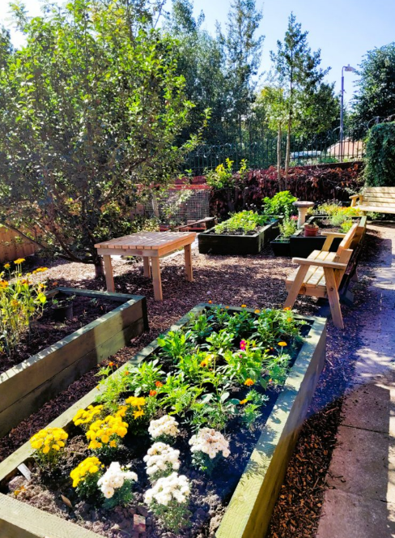

**Safe, strong and distinctive**:

**Case Study: Endeavour (Paws for Kids).**

Bolton’s Fund awarded a grant of £9,820 for a project to train local volunteers to become Domestic Abuse Community Champions.

Endeavour (Paws for Kids) is a community domestic abuse service in Bolton. They provide outreach support for people aged 16 and over who wish to leave or end relationships with an abusive partner. They provide practical support and essential equipment alongside bespoke safety plans and support packages.

The grant funded a volunteer training programme, along with the translation and print costs of posters, leaflets, and safety cards into eight community languages.

Due to the trained volunteers, the organisation has reported that they are seeing the immediate impact of people being introduced into their services at a much earlier stage than if the pathway had not been there.

To find further case studies please follow this link: [Bolton's Fund - Bolton CVS](https://www.boltoncvs.org.uk/funding/boltons-fund-2/).

