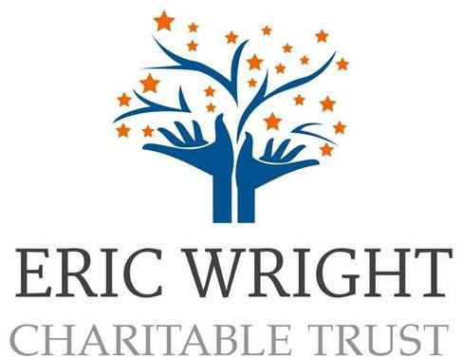

Eric Wright Charitable Trust Grants 2024

Information and Guidelines

Grants for organisations: up to £1000

Closing date: Sunday 24th November 2024

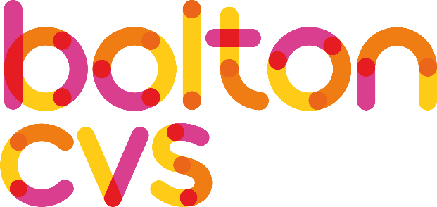
Background
Bolton CVS are delighted to be working in partnership with the Eric Wright Charitable Trust to administer the 2024 Eric Wright Trust Grants Programme.

The grants programme is aimed at small, grassroots voluntary and community groups in Bolton delivering activities that promote inclusion and wellbeing and encourage the participation of local people.

Small grants of up to £1000 are available for projects and activities that make a positive difference to the lives and wellbeing of people of all ages in Bolton.

Who are the grants for?
To be eligible, your group must be either:

- a constituted voluntary or community group, a registered charity.
- be based in and/or of benefit to people living in the Bolton local authority area.
- have an annual income of under £30,000 in the last financial year.
- Have completed any outstanding grant monitoring reports due from other grants and investments programmes administered by Bolton CVS.

What projects are we interested in funding?
All funded projects must help communities in one or more of the following ways:

- Support people to feel connected and more active in their communities.
- Encourage participation of local people in community projects.
- Support people to have a better quality of life e.g., improved mental and physical wellbeing.
- Enable people of all ages to develop new skills and knowledge.
- Promote partnership working between community groups.

How much can your group apply for?
The Eric Wright Trust Charitable Grants Programme provides voluntary and community groups across Bolton with the opportunity to apply for up to £1000 to support project and core costs of your organisation.

Up to 50% of your grant award can be used as a contribution towards the core running costs of your organisation (this includes operating costs relating to energy, fuel, rent, food, services, volunteer expenses, paying staff a living wage).

Please note: The grants programme will not fund activity that does not demonstrate significant community benefit.

There is a £1000 limit for the Eric Wright Charitable Trust Grants but we expect community groups to apply for the real costs rather than the maximum grant available.

Your group can receive a maximum of one Eric Wright Charitable Trust grant in a financial year.

Exclusions – Please note we do not give Eric Wright Charitable Trust grants:
- To organisations that have not completed the monitoring of a grant we previously awarded.
- To organisations with an annual income of over £30,000 in the last financial year.
- To organisations that do not operate with a charitable-type dissolution clause or an asset lock – if you are not sure, please contact Bolton CVS on 01204 546010.
- Towards trips, outings, meals, parties or any other one-off activity that does not demonstrate significant community benefit.
- For activities of a political or exclusively religious nature.
- To individuals or to organisations on behalf of individuals.
- Activities that commence or equipment purchased prior to confirmation of grant funding approval.
- To fundraise on behalf of another organization.

*Please note: Any capital equipment must be 100% related to the delivery of the project and demonstrate how it will help you to deliver one or more of the aims above.
Grant decisions

Once we have received your application, we will complete initial checks to ensure:

- That you meet the minimum standards for eligibility.
- You or the organisation you are applying on behalf of is eligible to apply for the fund.
- That you have completed all outstanding monitoring for any other applications you have that are managed by Bolton CVS.
- That you have answered all the questions.

If you meet all the above your application is then passed for assessment. Each application will be assessed separately by at least three volunteer trained grant assessors who will score your application according to the set criteria.

The total scores are then collated, and the decision will then be made.

Your application will be assessed against the following four criteria:
- The planning of the proposed project.
- How well the application explains the need for the project.
- The impact the proposed project will have on the lives of Bolton residents.
- Value for money.
Deadlines and How to Apply

Fund Opens: | Friday 11th October 2024
Deadline: | 11.59pm Sunday 24th November 2024
Go to Bolton CVS Funding web page for application form links*: | Click here: Bolton CVS Funding
Notification of outcome: | Please anticipate waiting about 8 weeks after the closing date for notification of the outcome of your application.

*Please note that you will need to have a login for the Bolton CVS website and have completed an Organisation Registration Form before you can access the ‘Grants Dashboard’ where you can access the application form.

Help to apply:
If your group needs to help to apply, please contact Bolton CVS on 01204 546010 or email funding@boltoncvs.org.uk

