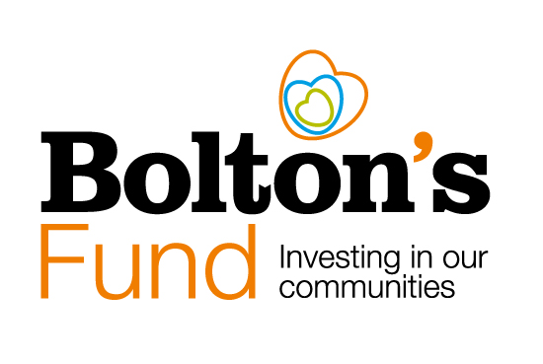

Social Value – Supporting your Bolton’s Fund Application

What is Social Value?

The term ‘social value’ relates to the broader impact a project or an initiative can have on society and the environment, beyond its direct objectives.

It emphasises the full value created by the project - beyond financial gains - and covers outcomes like improved community well-being, increased environmental sustainability and successful economic development.

Social Value and your Application to Bolton’s Fund

Please tell us in your application to Bolton’s Fund about the added social value your project will bring to Bolton. This could be to the environment, to the local economy as well as promoting inclusion, empowerment and happiness. For example:

- If your project involves local volunteers, it could bring new skills and expertise to Bolton.
- If your project builds in environmental benefits by reducing car use, reducing, re-using or recycling materials. Or by encouraging people to understand, enjoy and protect our wildlife, local nature reserves and green spaces.
- You could decide to purchase materials for your project from an independent retailer in Bolton, resulting in increasing the amount of money circulating within Bolton.
- Your project could require a new paid post. If you employed a Bolton resident, the resulting social value would be that you have contributed to the local economy.
- Your project could be working in partnership with a local business to harness additional skills and resources for the benefit of our community.
- You could decide to use apples grown in people’s gardens, collected by volunteers, to make apple pies for a community event. As a result, your wider social value may be empowered individuals and increased connections.

Bolton CVS Strong Together Training Programme
We regularly run training sessions about social impact and the value of being rooted to a place. The session focuses on giving you a good understanding of what social impact you may already be generating, how you can grow it, report it and celebrate it. It will help you know what the difference is that you are making; and consequently, so will your present and future funders.
Bolton CVS offers a range of specialist training courses designed to develop the skills and knowledge of the diverse Voluntary and Community Sector in Bolton. All our courses are tailored in line with what you tell us you need and are designed to be accessible to all levels of staff and volunteers.
Details of our ‘Stronger Together’ training programme can be found on our website here.

