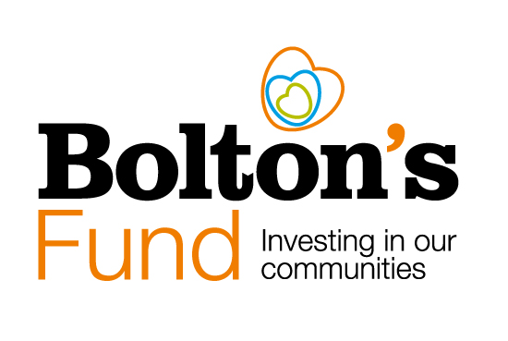
Social Enterprises

Social Enterprises

Social Enterprises

Bolton CVS definition of a Social Enterprise
A Social Enterprise is a business or organisation that combines commercial activities with a strong focus on achieving social or environmental goals.
Social enterprises can take various legal forms, aiming to balance financial sustainability and impact. An overview of their core characteristics is below.
Characteristics of a Social Enterprise
- Mission-Driven: Social enterprises are purpose-driven organisations, aiming to address a specific social or environmental issue. Their primary objective is to bring about positive change in society or the environment.
- Profit Generation: While they focus on social impact; social enterprises are still businesses. They generate revenue through commercial activities, such as selling goods or services, rather than relying solely on grants or donations.
- Social or Environmental Goals: The core of a social enterprise's mission is to achieve measurable and beneficial social or environmental outcomes.
- Reinvestment: Instead of distributing profits to shareholders, social enterprises reinvest their earnings back into their mission. This means that any financial surplus is used to further advance their social or environmental goals or to sustain and grow the organisation.
- Accountability and Transparency: Social enterprises often adhere to high standards of accountability and transparency, both in terms of financial reporting and the impact they achieve. They are typically committed to demonstrating their effectiveness in fulfilling their social mission.
- Diverse Legal Structures: Social enterprises can take on various legal structures, such as for-profit companies, nonprofits, cooperatives, or community interest companies, depending on the jurisdiction and their specific goals. The choice of legal structure often reflects their commitment to balancing financial sustainability and social impact.
- Innovation: Social enterprises often employ innovative approaches to solving social or environmental issues, blending business acumen with creative problem-solving.
- Market-Based Solutions: They leverage market forces and consumer demand to drive change. By offering products or services that meet market needs while addressing a social or environmental problem, social enterprises create a sustainable path toward their goals.
It's important to note that the terminology and definitions related to social enterprises may differ among organisations and regions. However, the overarching principle is the integration of profit-making activities with a commitment to making a positive societal or environmental impact.
If you are trading or, aim to trade, for the common good, or you are managing or aiming to create community assets, then you are eligible to apply for a grant from Bolton’s Fund.
Early Stage and Established Social Enterprises
Bolton’s Fund is available to enable early-stage enterprises to develop. It is also designed to support established enterprises improve their effectiveness.
If you are planning to set-up a social enterprise but do not have a legal structure yet, please see advice from the contacts below.
Do I have to be a Community Interest Company (CIC) to apply?
No you don’t. There are a range of business models and legal structures available. These include voluntary groups and registered charities, cooperatives and companies with social aims.
Advice on your legal structure
If you would like advice on your legal structure, please contact Elaine Butt, our Development Manager [e]: elaine@boltoncvs.org.uk

