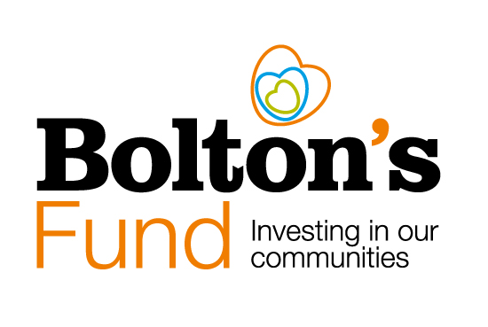
\sdf

Minimum Requirements for Applicants

Introduction
Bolton's Fund is a community grants pot that plays a crucial role in providing investment into Bolton's VCSE sector. Since 2019 it has played a vital role in driving innovation and fostering projects aimed at benefiting people and communities across the borough.

Bolton’s Fund is principally funded by Bolton Council with additional contributions from other organisations including: Bolton’s GP Federation, Bolton at Home and Bolton’s NHS Foundation Trust and the Sir James and Lady Scott Trust.

The overall goal of the Bolton 2030 Vision is to reach the destination goal of becoming:

Active, Connected and Prosperous. A great place to live, work, visit or study

The six priorities of Bolton’s Fund are:

- Start Well – giving children the best possible start in life.
- Live Well – improving the happiness and wellbeing of Bolton residents.
- Age Well – helping older people stay connected, active and healthy in their communities.
- Prosperous - supporting enterprise, inclusive employment and maximising social value for Bolton.
- Clean and Green - protecting, improving and enjoying our environment.
- Safe, Strong and Distinctive – creating safe, stronger, cohesive and more confident communities.

The priorities for this opportunity have been co-designed through reviewing the key priorities from the JSNA and working with Bolton Council’s lead for community cohesion, to ensure that the areas of focus for funding reflects the current issues facing Bolton residents and the place.

Eligibility and Minimum Requirements
These are the minimum standards you must meet to be eligible to apply for funding. If you need help with any of the points below, please don’t hesitate to contact the team at Bolton CVS, as we are here to help.

To be eligible to apply, your group or organisation must be:
- A constituted voluntary or community group*
- A registered charity
- Another type of constituted not for profit organisation.
- If you are applying for over £5,000, you need to be a registered charity or an incorporated not for profit.

Other eligibility factors include:
- Your group or organisation must be based and/or provide benefit to people living in the Metropolitan borough of Bolton (Bolton Council’s local authority area).
- Organisations must be up to date with the monitoring returns for any grants managed through Bolton CVS**.
- Have a charitable-type dissolution clause or an asset lock.
- Have a bank account in the name of the group (not an individual) with at least 2 signatories of people who are not connected or living at the same address if you are a community group or a charity.
- Have a bank account that is FSCS protected – we can’t pay money into accounts run by companies that offer e-money including prepaid cards and accounts such as PayPal.
- Have a minimum of 3 committee members or trustees if you are a community group or charity, or a minimum of 2 directors if you are a Community Interest Company.
- If your costings include payments to a trustee or committee member, your governing document must allow this and you must have appropriate procedures in place to manage any potential conflict of interest.
- We expect you to have appropriate insurance for your groups’ activities.
- Your sports coaches (volunteer or paid) must be registered with Bolton Council’s Register of Sports Coaches or another suitably recognised body.
- If you are working with children or young people and/or vulnerable adults, your group or organisation needs to have a named committee member or trustee responsible for safeguarding. Your Safeguarding Policy must outline clear steps to take in the event of an incident or disclosure, including who to inform and how to contact them.
- You must have safeguarding training for all staff and volunteers who have face-to-face contact with children and young people or vulnerable adults.
- You must have risk management policies in place including working safely with Covid-19.

*For unconstituted groups, please get in touch with the Bolton CVS team. We will ask you to tell us who is involved in your project and the name of an organisation that will be able to hold the funding on your behalf, if successful.

**We understand that there can be a variety of reasons why monitoring may be late or incomplete. Our development team are here to support organisations who need support with their monitoring. If your organisation has a recent track record with late, incomplete or inadequate monitoring returns, we reserve the right to provide this information to the grant panel.

Help and Further Information
If you would like to chat about a potential application or you need help with the application form, please contact us on:
Email us at - funding@boltoncvs.org.uk or phone 01204 546010

You can also refer to the funding information pages on the Bolton CVS website: https://www.boltoncvs.org.uk/funding.

Bolton Community and Voluntary Services (CVS)
Registered Charity No: 1003123
Registered Company No: 2615057
The Bolton Hub
Bold Street
Bolton
Greater Manchester
BL1 1LS
01204 546 010

info@boltoncvs.org.uk
www.boltoncvs.org.uk

