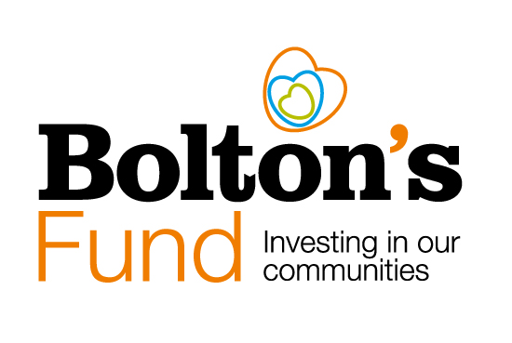

Bolton’s Fund
What we can fund

Introduction
Bolton's Fund is a community grants pot that plays a crucial role in providing investment into Bolton's VCSE sector. Since 2019 it has played a vital role in driving innovation and fostering projects aimed at benefiting people and communities across the borough.

Bolton’s Fund is principally funded by Bolton Council with additional contributions from other organisations including: Bolton’s GP Federation, Bolton at Home and Bolton’s NHS Foundation Trust and the Sir James and Lady Scott Trust.

This document gives detail about the eligible project costs that a grant from Bolton’s Fund will cover.

It also outlines the costs and organisations that cannot be funded by a grant from Bolton’s Fund.

Eligible costs

A grant from Bolton’s Fund can fund:
- Volunteer expenses
- Events that bring communities together
- To test a new idea in your community of for your beneficiaries.
- Equipment – please note that you will need to explain why you need this equipment. We will not fund the purchase of equipment for a one-off activity or event.
- Reasonable transport costs if transport is a barrier to people participating in your project (you will need to justify this in your application.)
- Sessional worker, project workers, coaching costs (or salaries for larger projects.) These need to be in line with recognised pay scales or hourly rates for the type of work you are doing.
- We welcome organisations who pay and/or are accredited Living Wage employers (for more information see: livingwage.org.uk).
- Reasonable contributions towards project running costs. For example, room hire or insurance.
- Training costs. (Don’t forget to check out the free training run by Bolton CVS.)

Ineligible costs

We will not fund:
- Trips, outings, meals, parties or any other one-off activity that does not demonstrate significant community benefit.
- The purchase of alcohol.
- Activities of a political or specific religious nature.
- Projects that will be primarily of benefit to people living outside the Bolton Local Authority Area.
- Work that statutory bodies (such as schools or local authorities) have a duty to fund.
- Local government or NHS bodies.
- Wages of sports coaches and instructors (paid or volunteers) who are not listed on Bolton Council’s Sport Coaches and Instructors Register, where the grant is for work with people aged under 18 years’ old.
- Individuals or organisations applying on behalf of individuals.
- Costs to be passed on to other organisations, for example, Parent Teacher Associations (PTA’s) applying on behalf of schools.
- Project and delivery costs incurred or those that are paid for, before a grant is confirmed.
- Projects taking place outside of the UK.
- Deficit funding or repayment of loans, interest or fines.
- Fundraising for another organisation including applying to fund staff or equipment for another organisation unless grant guidelines have specific provision for this.
- Expenses unrelated to the funded project. Bolton’s Fund grants are awarded for specific projects or activities, and the funds must be used for the purposes outlined in the project proposal. Please see the Bolton’s Fund Standard Terms and Conditions for further clarification (https://www.boltoncvs.org.uk/funding/boltons-fund-2/ )

Help and Further Information

If you would like to chat about a potential application or you need help with the application form, please contact us on:
Email - funding@boltoncvs.org.uk or phone 01204 546010
You can also refer to the funding information pages on the Bolton CVS website: https://www.boltoncvs.org.uk/funding.

Bolton Community and Voluntary Services (CVS)
Registered Charity No: 1003123
Registered Company No: 2615057
The Bolton Hub
Bold Street
Bolton
Greater Manchester
BL1 1LS
01204 546 010

info@boltoncvs.org.uk
www.boltoncvs.org.uk

