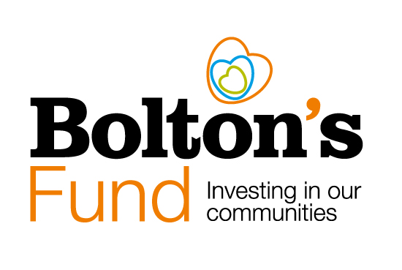

Bolton’s Fund Decision Making Process

The role of Bolton CVS in Bolton’s Fund

Bolton CVS are contracted by Bolton Council to administer Bolton’s Fund and provide support for groups across all stages of the application process.

Bolton CVS is not involved in the decision making process and does not make recommendations to the panel.

Support available from Bolton CVS includes:
- Sense checking draft applications to ensure an outcomes focus
- Support with working out a budget and how to report this on completion of the project
- Support with policies and procedures required
- Guidance to completing your monitoring form

Our Development Team are also available to help applicants identify other funding to complement and match Bolton’s Fund and to support and develop the knowledge and skills of your management committee, trustee board, staff and volunteers.

Background to Bolton’s Fund

Bolton’s Fund exists to support the VCSE sector in Bolton to grow and thrive. Bolton’s Fund grants will fund projects and activities that benefit people and communities across the Borough of Bolton.

We welcome applications from voluntary groups, community groups, charities or other constituted not for profit groups who are based in Bolton or who deliver activities in Bolton and that benefit Bolton residents.

All projects that receive funding will need to demonstrate how their proposed project will address one or more of the Bolton’s Fund priorities. The priorities are guided by Bolton 2030 Vision priorities.

Bolton’s Fund Priorities are:
- Start Well – giving children the best possible start in life.
- Live Well – improving the happiness and wellbeing of Bolton residents.
- Age Well – helping older people stay connected, active and healthy in their communities.
- Prosperous - supporting enterprise, inclusive employment and maximising social value for Bolton.
- Clean and Green - protecting, improving and enjoying our environment.
- Safe, Strong and Distinctive – creating safe, stronger, cohesive and more confident communities.

Since 2019, Bolton’s Fund has played a vital role in driving innovation and fostering projects aimed at benefiting people and communities across the borough.

The decision making process

Due Diligence and Initial Checks

Once we have received applications we will complete initial checks to ensure:
- The application is eligible to apply for the fund. Applicants meet our minimum standards for eligibility. Check the Bolton’s Fund webpage for information about our minimum standards. In addition, particular funding rounds of Bolton’s Fund may have additional requirements so always check the guidelines for each funding round.
- That applicants have completed all outstanding monitoring for any other grants awarded via Bolton CVS.
- That applicants have answered all the questions on the application form.
- We carry out a range of diligence checks which could include:
  - Evidence of activity in line with the governance document.
  - Governance information and submissions with regulators.
  - For Alliance/Partnership applications we will also carry out checks on any partners involved.
  - Additional safeguarding checks will be carried out where vulnerable adults or children are involved.

If all the minimum requirements are met, the application and any issues that arise via the due diligence process are passed to the assessment stage.

Assessment Process

Each application will be assessed independently by a minimum of three community grant assessors.

Scoring is decided according to set criteria.

The total scores are then collated and presented at a panel meeting where the assessors will meet to make the final decisions.

Bolton CVS is not involved in the decision making process and does not make recommendations to the panel.

Information about the Bolton’s Fund Grant Assessors

- Community assessors will include representatives from organisations who have previously applied to Bolton’s Fund.
- Assessors will include representatives from Bolton’s Fund partners including Bolton at Home, Bolton Council, Greater Manchester Integrated Care Partnership and Bolton Council Public Health.
- Grant Assessors regularly change.
- Grant Assessors include individuals with experience of the specific fund priorities in each round and include assessors with lived experience.
- All community assessors are volunteers. Out of pocket expenses for travel costs can be paid.
- No Bolton CVS staff, volunteers or trustees are involved in panel decision making.
- No local politicians or individuals preparing to stand for election are involved in decision making.
- Conflict of interest is managed through an open and transparent ‘declaration of interest’ process. Conflicts of interest are recorded when appointed as an assessor and at each panel meeting.
- Assessors do this work anonymously to protect themselves and ensure they are not subject to lobbying.

The Role of the Assessment Panel

The assessment panel works to the following ground rules:

Do
- Maintain confidentiality – don’t discuss applications with anyone else
- Be fair
- Judge the applications by set criteria
- Provide comments to back up your score
- Flag up any concerns in comments box
- Disclose any conflicts of interest to Bolton CVS as soon as you are aware of any

Don’t
- Introduce new criteria
- Ask the applicant for additional information
- Discuss issues outside the panel
- Allow one element of the project you don’t like to affect your scores in other areas

Scoring consistency between panel members is checked and managed as a group.

If panel members require additional information from an applicant, they request this via a Bolton CVS employee.

A base-line minimum score is set where applicants scoring below that baseline are not eligible for funding even where there are enough funds available.

Where there are not enough funds available:

- Scores are ranked and those scoring highest will be funded
- Where scores are closely grouped when ranked additional “tipping point” criteria will be considered see Tipping Factors.
- The panel has the option to recommend partial funding where certain elements of project delivery or costings are not accepted.
- The panel has the option to award funding with certain conditions attached.

In all cases the reason for the decision not to fund an applicant will be recorded at the meeting and agreed by the panel. The decision of the panel is final.

Tipping Factors

Tipping factor criteria may be used where there are not enough funds available and two or more applicants have scored equally. These could include:

- Specific outcome priorities as may be identified by the Bolton’s Fund Co-design group. For example, fund guidelines for a specific funding round may include wording which says something like, “we particularly welcome applications that address….” Or, “the panel will take into consideration….. “
- To get a wider range of beneficiaries
- To get a wider geographic spread.
- To fund applicants who have not been funded before or who haven’t received Bolton’s Fund funding in the current year.
- Where the applicant has a poor or weak monitoring track record for previously funded work.

Updated September 2023

Bolton Community and Voluntary Services (CVS)
Registered Charity No: 1003123
Registered Company No: 2615057
The Bolton Hub
Bold Street
Bolton
Greater Manchester
BL1 1LS
01204 546 010

info@boltoncvs.org.uk
www.boltoncvs.org.uk

